Dash
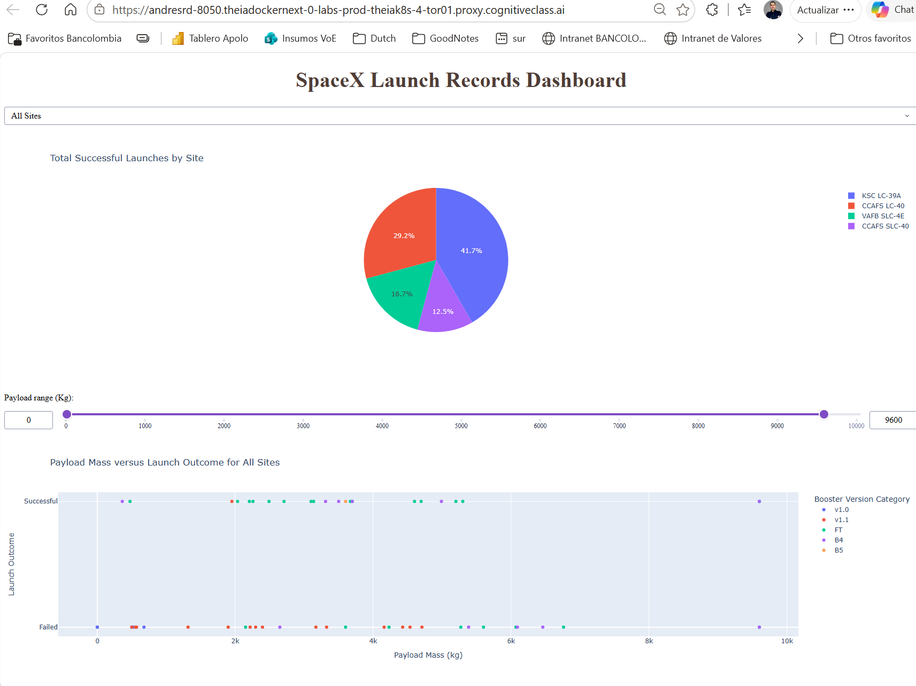

- Which site has the largest successful launches?
KSC LC-39A has the largest number of successful launches.
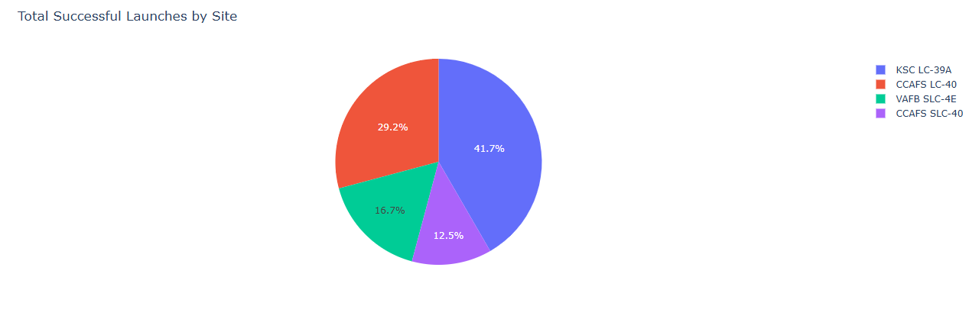

- Which site has the highest launch success rate?
KSC LC-39A shows the highest launch success rate.

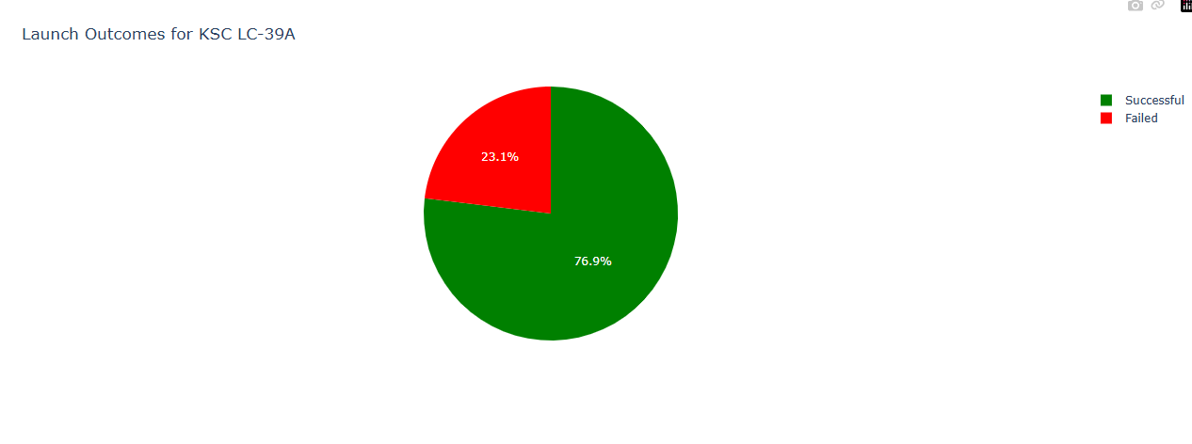

- Which payload range(s) has the highest launch success rate?
Payloads between approximately 2,000 kg and 6,000 kg show the highest success rates.

- Which payload range(s) has the lowest launch success rate?
Payloads below approximately 2,000 kg show the lowest success rates.

- Which F9 Booster version (v1.0, v1.1, FT, B4, B5, etc.) has the highest
launch success rate?
Booster Version FT has the highest launch success rate (in volume)
B5 only had a launch it was 100% successful.

